University of Technology of Applied Sciences
Brain Byte Website
Malik Sulaiman Ahmed Al Kindi 16s23093
Omar Said Saleh Al Riyami 16s230112
Ayah Moosa Said Al Balushi 16j21133
Mohammed Hamed Mohammed Al Barwani 16s23070

Table of Contents

Introduction
Purpose of the Website
Target Audience
Wireframe
Sitemap

- Introduction

The project aims to develop a website for promoting and showcasing the Brain Byte Cube, a premium magnetic speed cube designed for speedcubers. The website will serve as a platform to highlight the features, specifications, and benefits of the Brain Byte Cube, enticing potential customers to make a purchase.

- Purpose of the Website

The primary purpose of the website is to provide information about the Brain Byte Cube and its unique features. It aims to create awareness among speedcubers about the advantages of using the Brain Byte Cube, such as its calibrated magnets, optimized structural design, and easy-to-use tensioning system. Additionally, the website will facilitate online purchases, allowing customers to buy the Brain Byte Cube directly from the platform.

- Target Audience

The target audience for the website includes speedcubers of all skill levels, ranging from beginners to advanced enthusiasts. The website will cater to individuals who are passionate about solving Rubik's cubes and are seeking high-quality speed cubes to enhance their performance. Additionally, the website will target parents and gift buyers looking for premium speed cubes as gifts for their children or friends who enjoy speedcubing.

- Wireframe

The wireframe of the website includes a visually appealing homepage featuring the Brain Byte Cube prominently. The navigation menu allows users to easily access different sections of the website, including product information, about us, and a blog section. The homepage also includes social media links for further engagement.

Main Page WireFrame
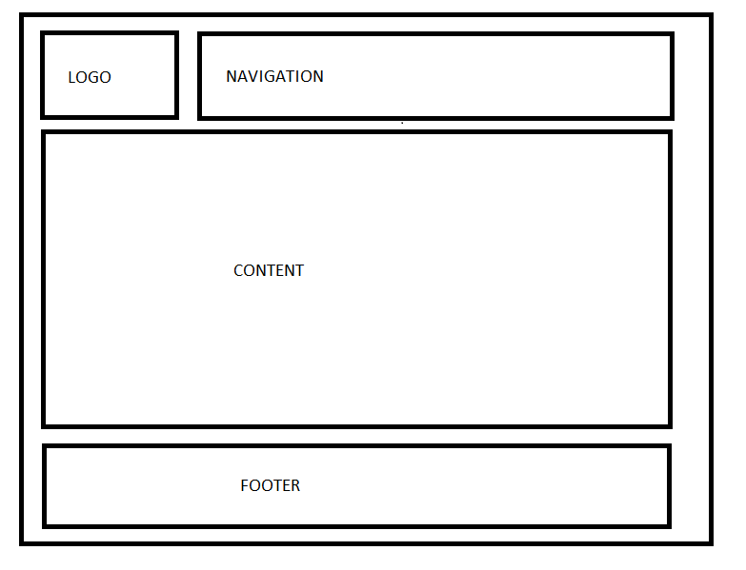

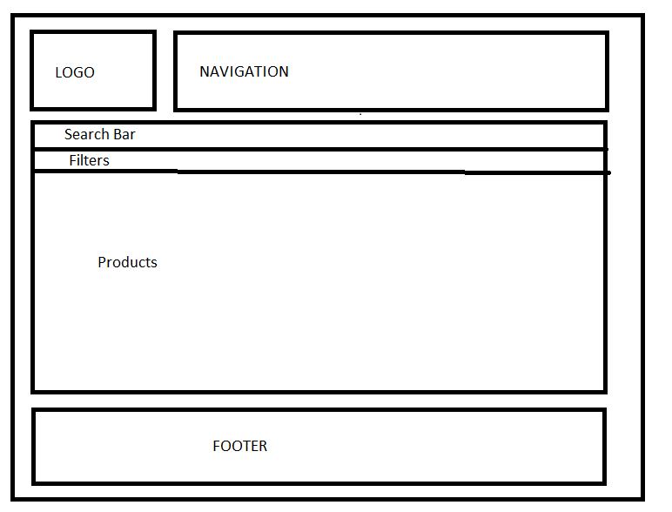
Products Page WireFrame

About Page WireFrame

Blog Page WireFrame

- Sitemap

The sitemap of the website outlines the hierarchical structure of its pages, ensuring intuitive navigation for users. The main pages of the website include:

Home: Provides an overview of the Brain Byte Cube and its features.

Products: Displays detailed information about the Brain Byte Cube, including specifications and pricing.

About: Offers insights into Brain Byte, the company behind the Brain Byte Cube, and its mission.

Blog: Features informative articles and updates related to speedcubing and the Brain Byte Cube.

Main
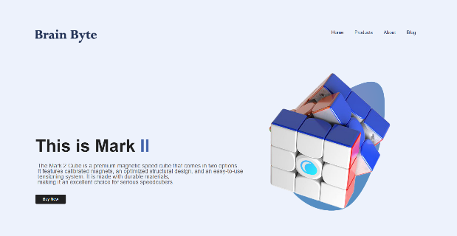

Products About
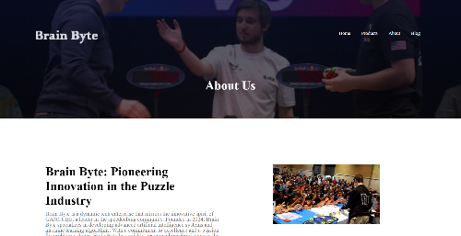
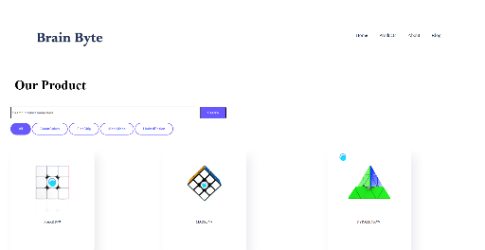

Blog
